Nepal college of information technology

 | Assessment  Fall 2012 | Time : 3 hrs
Program : BE ELX  Semester : Fall(V) |  | FM : 100
Subject : Signal & System |  | PM : 50

Candidates are required to give their answers in their own words as far as practicable.
The figures in the margin indicate full marks.

Attempt all the questions.

 | - Differentiate the given signal with suitable examples:  i) Deterministic & Random  ii) Periodic & Aperiodic  iii) Even & Odd  iv) Energy & Power  - Given the signal x(t) as shown below. Sketch the following signals  i) x(t+1) ii) x(3t/2 + 1) iii) 3x(t)  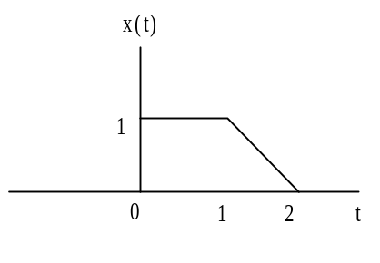 | 10  5
- X( | - State and prove the necessary and sufficient condition for the stability of LTI systems.  - Write down the properties of Fourier transforms. Also Prove modulation property of continuous time Fourier transforms. | 6  9
 | - Determine the fourier series for the given impulse train  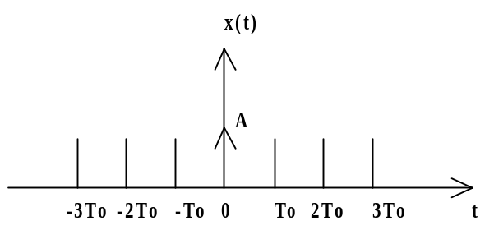  - Determine DTFS coefficient of the given discrete-time signal  x(n) = sin(4πn / 21) + cos(10πn / 21) + 2.  Also define DTFS. | 7  8
 | - Compute IDFT of X(k)={6,0,2,0} by using Linear Transformation Method.  - Perform Circular Convolution between two sequences x₁(n) and x₂(n) where x₁(n) = {1,2}, x₂(n)= u(n)-u(n-4)  Take N=4 points | 7  8
5 | - Define the term convolution. Find the convolution of two rectangular pulses having width 2τ & unit amplitude.  b) State and prove Parseval’s Power Theorem. | 8  7
6 | - Determine the total solution of the given difference equation  y(n) = 5/6 y(n-1) – 1/6 y(n-2) + x(n) when the forcing input function is x(n) = 2^{n} for n≥0 and zero otherwise  b) Describe in detail about a model of a communication system. | 9  6
7 | Write short notes on (Any Two)  - Elements of LTI system  - Cross Correlation & Auto Correlation  - Elementary Function | 2*5

